The solar system

Top 10 facts about the solar system

1. The solar system has eight planets
The solar system is all the planets and other things in space that orbit (go around) our sun.
This includes the planets Earth, Mercury, Venus, Mars, Jupiter, Saturn, Uranus and Neptune as well as the dwarf planet Pluto, asteroids, meteoroids and comets.
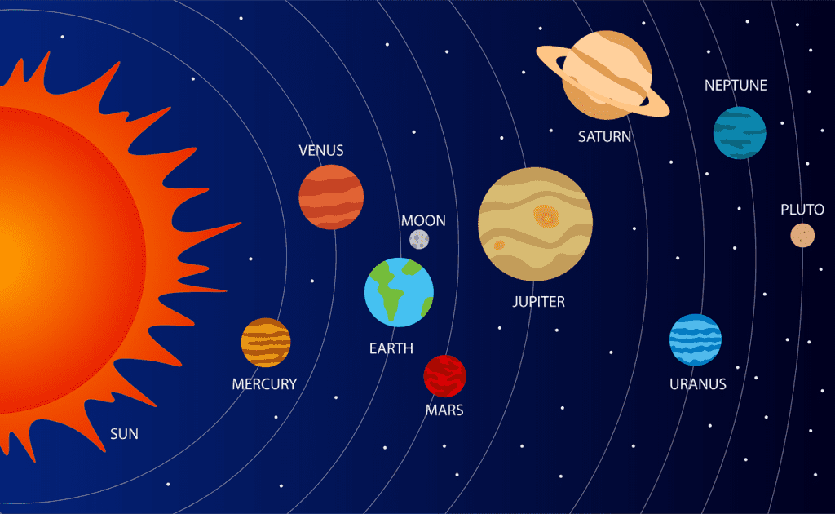
Space 1: Solar system

2. Earth is only a very small part of the solar system
Earth is a big place but within the solar system it is quite small. It would take 1.3 million planets the size of Earth to fill up the sun. Earth is a lot smaller than planets like Jupiter and Saturn.

3. The solar system formed 4.6 billion years ago
The solar system was formed 4.6 billion years ago from a cloud of gas and dust called the solar nebula. A shock wave from a nearby supernova (big star) explosion probably started it. The Sun formed in the centre, and the planets formed around it.

4. The solar system is part of the Milky Way
The solar system is part of the Milky Way. There are at least between 250 to 500 billion stars in our Milky Way galaxy – there might even be more. That's at least 30 times more stars in The Milky Way than there are people on Earth.
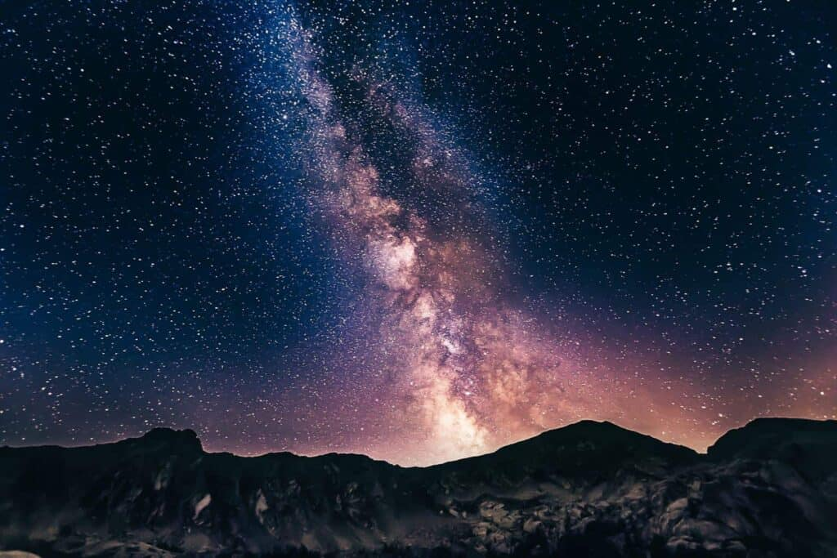
Space 2: Milky way

5. The Sun is 93 million miles from the Earth
This is the same as taking 1000 trips to Australia! Even though it's so far away the light from the Sun only takes 8 minutes to travel to the Earth.

6. All planets and the Sun in the solar system are shaped like balls
Once upon a time people thought the Earth was flat. We now know, and can prove through satellite pictures, that it looks like a ball. All planets, as well as the Sun, are balls too.

7. Planets in our solar system have different temperatures
The hottest planet is Question/Vraag1.4 with an average temperature of 460°C and the coldest planet is Uranus with an average temperature of -220°C. By comparison, Earth's average
temperature is 15°C.

8. There are 181 moons in the solar system
Scientists are always discovering more moons in the solar system and are currently arguing over whether Saturn or Jupiter has more moons. Currently Jupiter and Saturn both have 53 confirmed moons but they also both have more than 30 moons NASA haven't confirmed.
There are also 552 894 asteroids and 3 083 comets in the solar system!

9. Neptune was the last planet to be discovered in the solar system
Neptune was the last planet to be discovered. On the night of 23rd September 1846 astronomers discovered Neptune through a telescope.
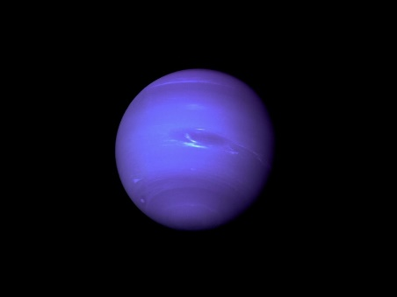
Space 3: Neptune

10. You can see Venus from Earth
You can see some of the solar system from Earth. For example, we have all seen the sun and our moon. You can also sometimes see Venus, which is also known as the evening or morning star. Yellow clouds made of sulphur cover the entire planet causing light from the sun to reflect off the surface meaning we can often see it at night. It is usually the first 'star' you will spot.
This makes Venus the second brightest object in the night sky after the Moon.
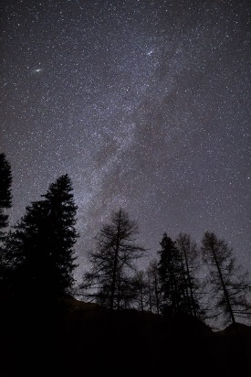

Space 4: Venus

Planets:

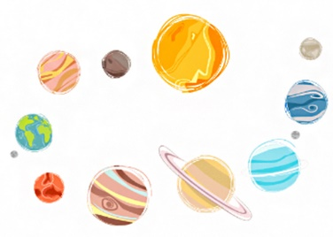
As per the Scientific Union of Astronomers, an object is said to be a planet if —
- It orbits around a star.
- It is big enough to look like a sphere.
- It has a specific orbit that is not occupied by any other heavenly body.

Differences between the inner and the outer planets:
Inner planets Outer planets
Orbits are short. Orbits are long.
They spin slowly. They spin faster.
Do not have rings around them. Have ring-like structures around them.
Have very few moons. Have many moons.
Made of rocks, metals, etc. Made of gases and liquids.

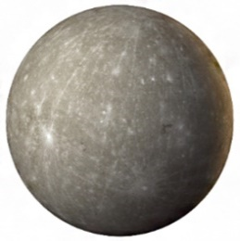
- Mercury:
Space 5: Mercury
  - It is the smallest planet in the solar system and is also the closest to the Sun.
  - It does not have an atmosphere. So, the days are very hot and the nights are equally cold. Mercury's one year is of 88 Earth days.
  - It does not have any moon.
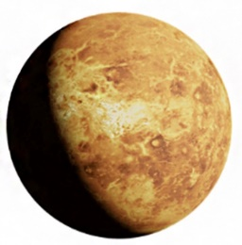
- Venus:
Space 6: Venus
  - It is the 2nd planet from the Sun.
  - Its size is similar to that of the Earth.
  - However, it is surrounded by a toxic and thick atmosphere of carbon dioxide. Therefore, it is the hottest planet in the solar system.
  - 225 Earth days make one year on Venus.
  - It has no moons.
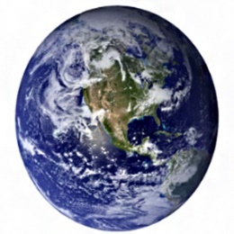
- Earth:
Space 7: Earth
  - It is the only known planet in the solar system with the presence of liquid water and life on it.
  - The Earth's atmosphere is formed of a mixture of many gases suitable for the survival of life. This atmosphere shields the Earth from the harmful sun rays.
  - 365 days make 1 year on Earth.
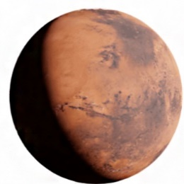
  - It has one moon.
Space 8: Mars
- Mars:
  - It is the 4th planet from the Sun.
  - It has a deserted, cold surface with a very thin atmosphere around it.
  - 687 Earth days make 1 year on Mars.
  - It has 2 moons. Mars is the only inner planet to have two moons.
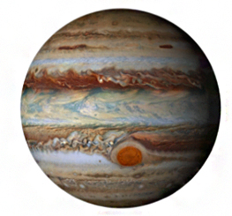
- Jupiter:
Space 9: Jupiter
  - It is the 5th planet from the Sun and the first outer planet.
  - It is a gas giant and has faded dust rings around it.
  - Jupiter is the largest planet in the solar system.
  - 4333 Earth days make 1 year on Jupiter.
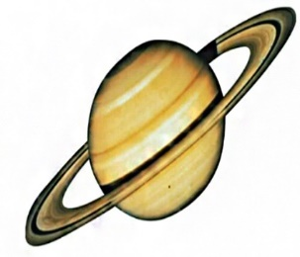
  - It has 79 moons.
Space 10: Saturn
- Saturn:
  - It is the 6th planet from the Sun.
  - It has a system of rings around it. Galileo observed these in 1610 for the first time.
  - Around 10 585 Earth days make one year on Saturn.
  - It has the highest number of moons, that is, 82.

- Uranus:
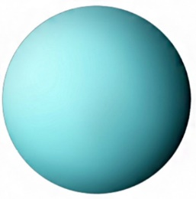
  - It is the 7th planet from the Sun and also the third biggest planet.
Space 11: Uranus
  - Uranus has 13 known narrow rings around it.
  - The bright blue colour of the planet is because of the presence of methane in its atmosphere.
  - Around 30 660 Earth days make 1 year on Uranus.
  - It has 27 moons.
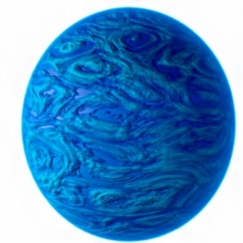
- Neptune:
Space 12: Neptune
  - It is the 8th planet from the Sun.
  - It is an icy, dark blue giant planet of our solar system.
  - Neptune is surrounded by rings made of dust and debris.
  - Around 60 190 Earth days make 1 year on Neptune.
  - Neptune has 14 known moons.

A dwarf planet is a small planetary-mass object that is in direct orbit of the Sun, smaller than any of the eight classical planets but still a world in its own right. The prototypical dwarf planet is Pluto.

Why is Pluto a Dwarf Planet?
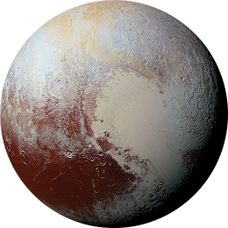
- Pluto was a part of our solar system before 2006.
Space 13: Pluto
- However, in 2006 it was categorised as a dwarf planet due to its size and the presence of other objects in its orbit.
- Pluto's orbit differs from the rest of the planets; it is inclined and has an oval shape.
- It is situated in the Kuiper belt region.
- Around 90 520 Earth days make 1 year on Pluto.
- Pluto has 5 moons, the largest one called Charon.

